CHAPTER 3: RESEARCH METHODOLOGY

3.1 INTRODUCTION
This chapter presents the research methodology adopted in the development and evaluation of the proposed Federated Intrusion Detection System (FL-IDS). It outlines the research design, data collection methods, experimental procedures, and evaluation techniques used to validate the system. The methodology follows an artefact-based research approach, where a functional system is developed and evaluated to address the research problem.

3.2 RESEARCH DESIGN
The study adopts a quantitative and experimental research design. The quantitative approach is used to observe measurable system behaviors, while the experimental design enables controlled simulations. The research involves designing the artefact, running simulations, and observing system performance under different conditions.

3.3 RESEARCH QUESTIONS

This study was guided by the following research questions:

RQ1: How can a federated intrusion detection artefact be designed to support distributed intrusion detection in IoT/network environments?

RQ2: How effectively can machine learning, specifically Random Forest, classify multiple intrusion categories using a labelled IDS dataset?

RQ3: How can visual analytics such as confusion matrix heatmaps, attack distribution charts, and F1-score graphs improve interpretation of IDS evaluation results?

RQ4: What limitations affect the proposed artefact in relation to real-time traffic analysis, federated deployment, concept drift, and rare attack detection?

3.4 RESEARCH OBJECTIVES

The objectives of the study were:

RO1: To design and implement a federated intrusion detection artefact capable of supporting distributed IDS simulation.

RO2: To evaluate the effectiveness of a Random Forest classifier in detecting and classifying multiple intrusion categories using the NSL-KDD dataset.

RO3: To integrate visual analytics into the artefact in order to support interpretation of intrusion detection results.

RO4: To identify the limitations of the proposed artefact and propose future improvements relating to real-time deployment, drift adaptation, and rare attack detection.

3.5.0 RESEARCH HYPOTHESES
The study was guided by the following hypotheses:
3.5.1 Alternative Hypothesis (H₁)
The proposed federated intrusion detection framework incorporating machine learning and robust evaluation mechanisms achieves high detection performance and reliability under intrusion detection conditions.
3.5.2 Null Hypothesis (H₀)
The proposed federated intrusion detection framework does not achieve reliable or significantly improved intrusion detection performance.

3.5.3 Testing of Hypotheses
Hypotheses are tested through simulation of multiple clients, observation of system behavior under IID and Non-IID conditions, and monitoring system responsiveness and stability.

3.5.4 Artefact Development Approach
The research follows an artefact-based methodology. The artefact developed is a Federated Intrusion Detection System simulation platform capable of dataset loading, partition generation (IID and Non-IID), federated training simulation, and real-time monitoring.

3.6 SYSTEM ARCHITECTURE OVERVIEW
The system consists of three major layers: Edge Layer (IoT devices and local training), Federated Learning Layer (aggregation server and model updates), and Security Layer (drift detection and adversarial robustness mechanisms).
The proposed system adopts a hybrid architecture consisting of two major components:
- Java-based graphical interface
- Python-based machine learning engine
The Java component provides:
- Dataset loading
- Dataset preview
- Partition generation
- Federated node simulation
- Result visualization
The Python component performs:
- Data preprocessing
- Random Forest training
- Intrusion classification
- Metrics computation
- Chart generation

The two components communicate through generated output files such as:
- metrics.json
- confusion_matrix.csv
- attack_summary.csv
3.7 DATA COLLECTION

The study primarily utilized the NSL-KDD dataset for intrusion detection evaluation.

The dataset was selected due to:

Reduced redundancy compared to KDD Cup 1999

Balanced class representation

Support for multi-class intrusion detection

Wide adoption in IDS research

The dataset includes both benign and malicious traffic records representing attack categories such as:

Denial of Service (DoS)

Probe attacks

User-to-Root (U2R)

Remote-to-Local (R2L)

3.8 DATA PREPROCESSING

Data preprocessing was performed to prepare the dataset for machine learning evaluation.

The preprocessing stage involved:

Label extraction

Feature selection

Removal of invalid records

Numerical conversion where applicable

Training and testing partition generation

The label column was separated from the feature space to create:

X (feature matrix)

y (target labels)

The processed data was then divided into training and testing subsets.

3.9 DATA PARTITIONING STRATEGY
Data is partitioned into IID (equal distribution) and Non-IID (skewed distribution) scenarios to simulate realistic IoT environments where different devices observe different traffic patterns.

3.10 FEDERATED LEARNING SIMULATION
The simulation involves client selection, local training, aggregation of updates, and global model update across multiple rounds. This mimics the federated learning process.
The study incorporated federated learning concepts through simulated client partitioning.
Dataset partitions were generated to simulate distributed network nodes operating independently. Both IID and Non-IID partitioning approaches were considered to emulate heterogeneous network environments.
The federated simulation process involved:
- Dataset partition generation
- Client node assignment
- Local training simulation
- Aggregated evaluation analysis
Although the current implementation simulates federated learning behavior, it establishes a foundation for future fully distributed implementations.
3.11 MACHINE LEARNING MODEL SELECTION
The Random Forest algorithm was selected as the primary classification model.
The selection was motivated by:
- High classification accuracy
- Robustness to overfitting
- Strong multi-class performance
- Efficient handling of large feature spaces
- Strong performance in prior IDS studies
Random Forest constructs multiple decision trees and performs classification through majority voting across the ensemble.
The implementation utilized the Scikit-learn library within Python.

3.12 EVALUATION METRICS
The system is evaluated based on functionality, partition correctness, simulation behaviour, and scalability. Additional conceptual metrics include accuracy, precision, recall, and robustness.

3.12.1 Accuracy
Accuracy measures the proportion of correctly classified instances.
$$Accuracy=\frac{TP+TN}{TP+TN+FP+FN}$$3.12.2 Precision
Precision measures the proportion of predicted positive instances that are correctly classified.
$$Precision=\frac{TP}{TP+FP}$$3.12.3 Recall

Recall measures the proportion of actual positive instances correctly identified.

$$Recall=\frac{TP}{TP+FN}$$3.12.4 F1-score

F1-score provides a harmonic balance between precision and recall.

$$F1=2×\frac{Precision×Recall}{Precision+Recall}$$3.12.5 Confusion Matrix

The confusion matrix was used to evaluate classification performance across multiple attack categories.

3.13 TOOLS AND TECHNOLOGIES
The implementation used the following technologies for development and evaluation: Java, NetBeans IDE, Maven, Swing and the CSV datasets.
Technology | Purpose
Java | GUI development
Java Swing | Interface design
Maven | Management of dependences
Python | Machine learning engine
Pandas | Data processing
Scikit-learn | Model training
Matplotlib | Chart generation
Git/GitHub | Version control
Table 3.1 Tools and Technologies
3.14 VISUAL ANALYTICS
Visual analytics techniques were integrated into the artefact to improve interpretability of the intrusion detection results.
The generated visualizations included:
- Confusion matrix heatmaps
- Attack distribution bar charts
- Per-class F1-score charts
- Actual versus predicted distribution plots
- Overall metric comparison charts
Matplotlib was used to generate the visual representations.

3.15 DRIFT AWARENESS AND ADAPTIVE CONCEPTS
The study also considered concept drift awareness within intrusion detection environments.
Drift-aware concepts discussed include:
- KS-Test
- Page-Hinkley
- ADWIN
- Mahalanobis Distance
These approaches provide mechanisms for identifying changes in data distributions and evolving intrusion patterns.
Although full online drift adaptation was not implemented within the current artefact, the concepts were integrated into the theoretical framework and evaluation discussions.

3.16 ETHICAL CONSIDERATIONS
The study utilized publicly available benchmark intrusion detection datasets. No personal or confidential user data was collected during the research process.
The artefact was developed strictly for academic and defensive cybersecurity research purposes.

3.17 LIMITATIONS OF METHODOLOGY
Limitations include simulated training, absence of real deployment, and limited quantitative metrics.

3.18 SUMMARY
This chapter presented the methodology used in the development and evaluation of the proposed FL-IDS artefact. The chapter described the research design, datasets, preprocessing techniques, machine learning model selection, evaluation metrics, and visual analytics approaches.
The next chapter presents the implementation and system development details of the artefact.

RESEARCH METHODOLOGY FLOW DIAGRAM
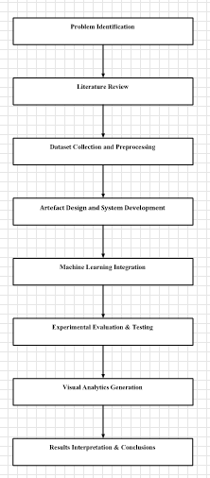

Figure 3.1: Research Methodology Flow

PROPOSED FL-IDS SYSTEM ARCHITECTURE
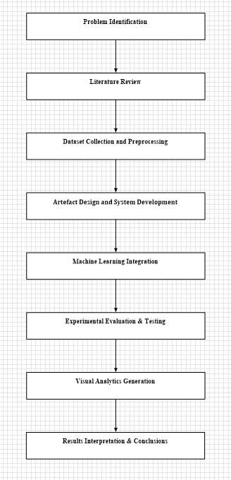
Figure 3.2: Proposed FL-IDS System Architecture
PROPOSED FL-IDS ARCHITECTURE
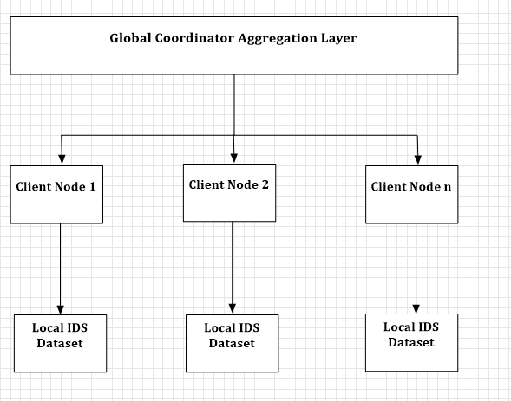
Figure 3.3: Federated Learning Simulation Model

MACHINE LEARNING EVALUATION PIPELINE
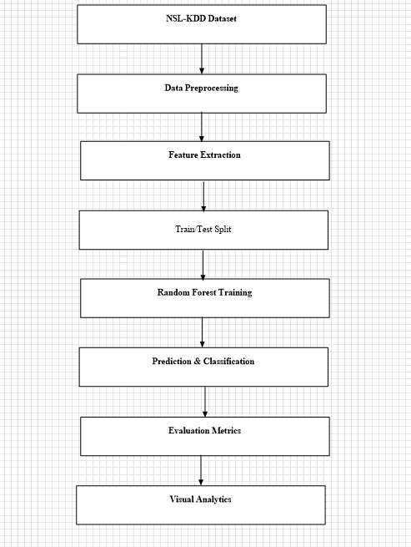
Figure 3.4: Machine Learning Evaluation Pipeline

UML DIAGRAMS
Use cases
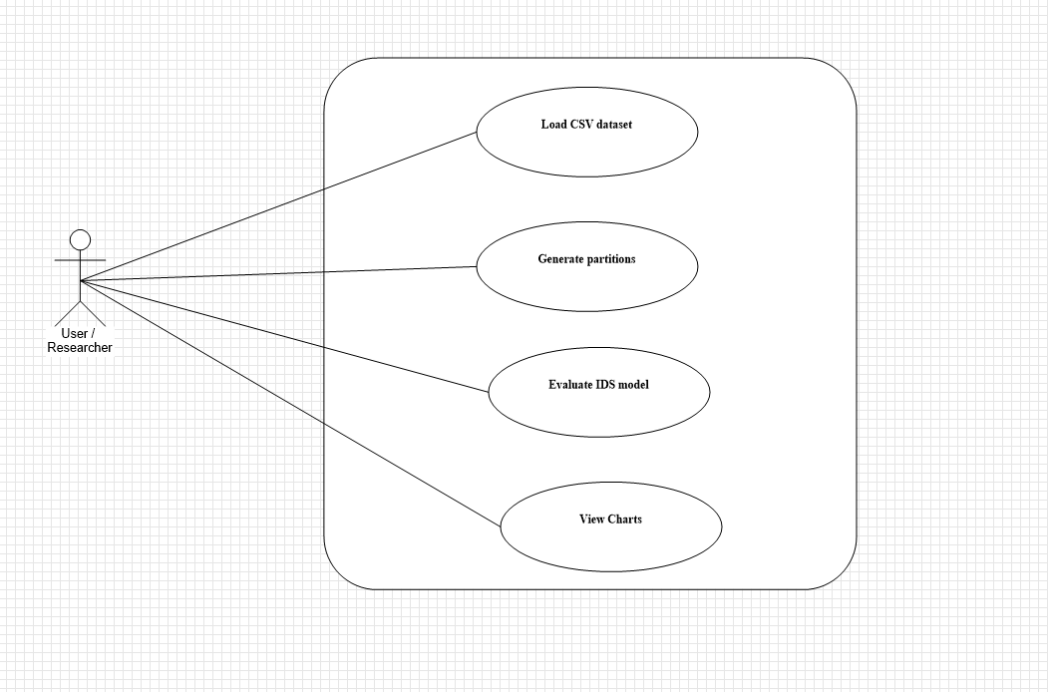
Figure 3.5: FL-IDS Use Case Diagram
Figure 3.5: FL-IDS Use Case Diagram

ACTIVITY DIAGRAM
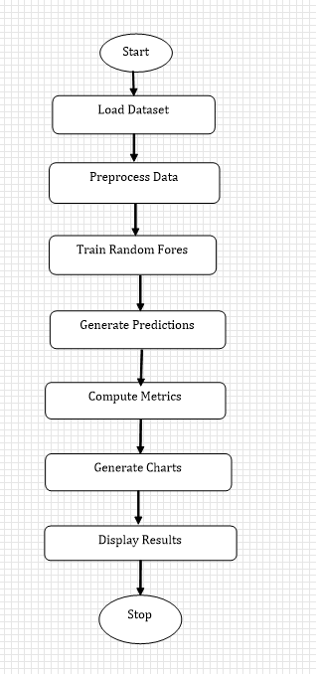

Figure 3.6:IDS Evaluation Activity Diagram

